Events
General information
We have already encountered event handlers several times and even used them in both object modules and form modules. It's time to understand in detail their structure, areas of application, and also get acquainted with a new metadata object - event subscriptions.
In the process of working with various metadata objects, such as catalogs, documents, registers, the user invariably encounters the fact that various events are triggered for these objects, as well as for their forms. For example, when a new document is created in interactive mode, the Filling event occurs in the object module, OnCreateAtServer and OnOpen in the form module (in fact, the list of events in this case is larger, but we are considering the most popular ones). Some events have standard platform behavior that can be overridden by changing the StandardProcessing parameter in the event handler from True to False. For example, a form field with the “Text box” type has a StartChoice event; if you disable standard processing in this event, then instead of the standard behavior, which depends on the type of attribute associated with the field (opening an object selection form for the reference attribute, opening an input field numbers for attributes with the type Number, etc.), nothing will happen.
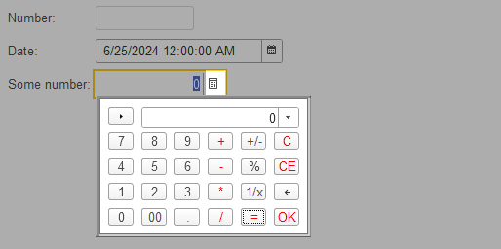
This is what the standard behavior of a choice button click looks like for a field with a numeric value type.
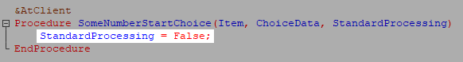
This way you can disable the standard behavior of the platform for a field.
In addition, you can create your own event processing algorithm in a handler procedure of any events. Using the form field and StartChoice event as an example, you can disable standard processing and then open a custom form for a special selection in certain cases.
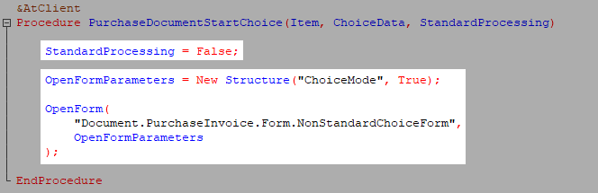
How can I find out what events an object, a form, or a form element have?
There are some differences between here, let's look at all the possible options:
- List of events of object/manager/record set modules/configuration root modules (application, session, external connection module)
A list of all events can be found in the list of module procedures and functions
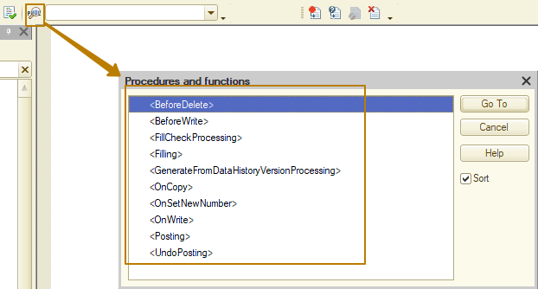
Event handlers that can be assigned are listed here in triangle brackets. When you click the "Go to" button or double click in the list, the selected event handler will be added to the module. Handlers that have already been assigned are no different in this list from other procedures and functions that are not event handlers.
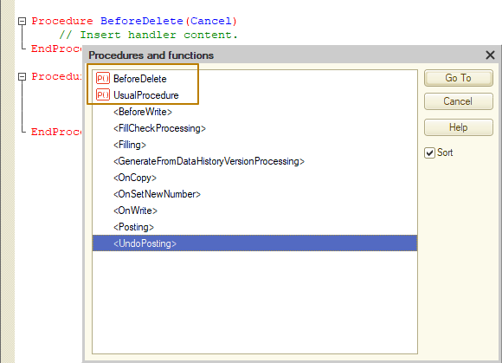
Another feature of event handlers in these modules is that they must have standard names. For example, the BeforeWrite event handler procedure must have the name BeforeWrite. If you assign the name BeforeWrite to your own procedure, it will automatically be considered a handler for the event of the same name, even if the parameters of such a procedure differ from the standard ones
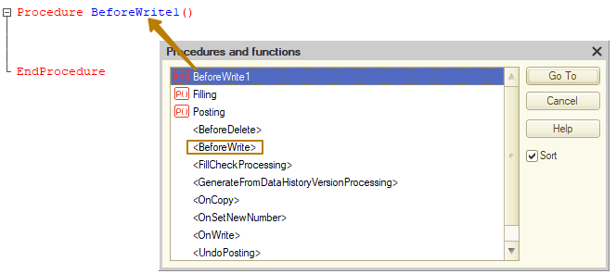
This screenshot shows that the module has a BeforeWrite1 procedure, and in the list of procedures and functions of the module it is possible to create a BeforeWrite event handler.
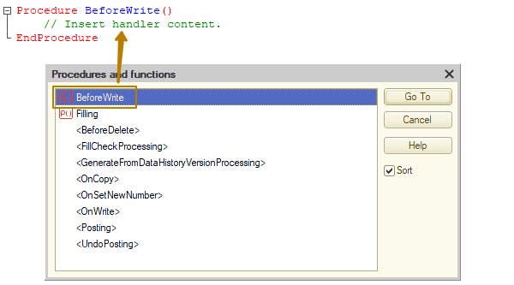
I changed the name of the procedure from BeforeWrite1 to BeforeWrite and now in the list of procedures and functions there is no event handler for the BeforeWrite event available for creation, because a procedure with the same name already exists, which means it is considered an event handler.
- The list of form element events can be found on the properties palette
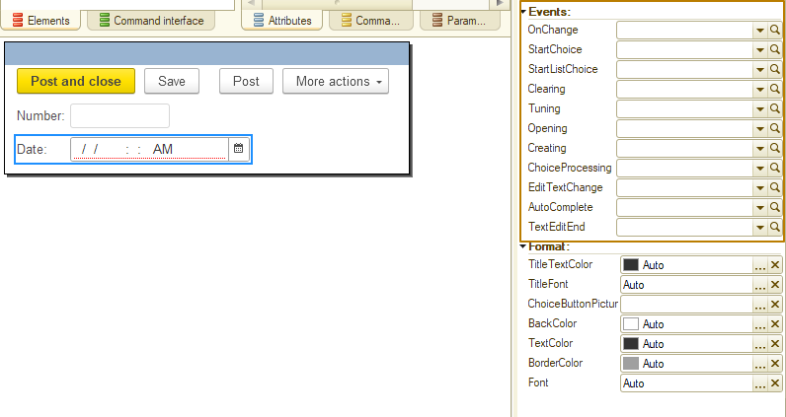
and also in the element's context menu
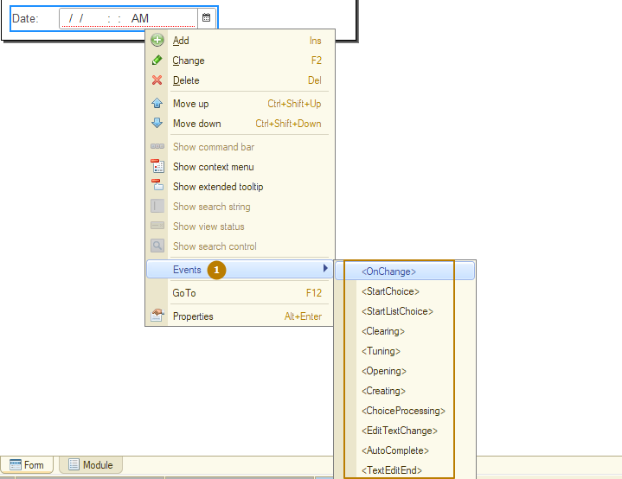
The difference is that in form modules, the events of the form elements and the form itself must be explicitly associated with handlers for these events. The names of the event handler procedures can be anything, although I recommend leaving the default values in most cases (a little further we will look at exceptions when non-standard names should be used). For form events, the names of the handler procedures by default coincide with the names of the events; for form elements, the platform assigns the procedure name as <FormElementName> + <EventName>.
For example, if you create a handler for the OnChange event for the Carrier form field from the properties palette or context menu, the resulting procedure name will be CarrierOnChange(). From the properties palette you can not only create new handler procedures, but also assign existing ones; this is the difference between form modules and other modules.
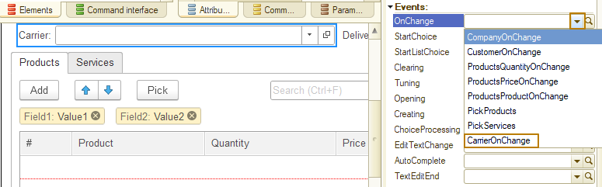
If you need to create a common handler for different fields, you can create a procedure and then specify it as an event handler for multiple form elements. In this case, I recommend giving the procedure a name that is not tied to a specific form element.
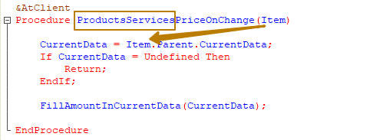
Let's look at an example. We have 2 tabular sections in the document: Products and Services. In both tabular sections there is a Price field, when changing the value in which you need to recalculate the amount in the row. Since in this case only the name of the tabular section differs, you can write an event handler that applies to both tabular sections:
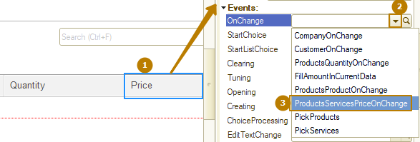
Note: The list of handlers available for selection is populated based on the number of procedure parameters. Those, if you have a procedure with one parameter in your form module, it will be offered for selection for all events whose handlers must have one parameter.
You must carefully modify or remove event handlers in form modules because the platform does not control how the event is associated with the handler when you rename or delete a procedure in a module. If a non-existent handler is specified for an event, this is the same as if the handler was not specified at all, i.e. the event will be processed in the standard way.
You can find out that a non-existent handler is specified for an event if you try to go to the handler from the properties palette or from the context menu:
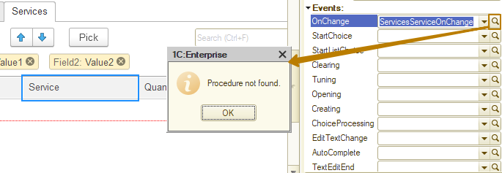
Therefore, I recommend making changes from the Properties palette:
- If you need to rename a procedure so that it remains an event handler, rename it in the desired event field on the Properties palette. After you finish editing (you can click on any other property), the platform will offer to rename the existing procedure in accordance with the changes made. If you refuse, a new handler procedure with the given name will be created in the form module; the old procedure will also be preserved, but will no longer be a handler for this event.
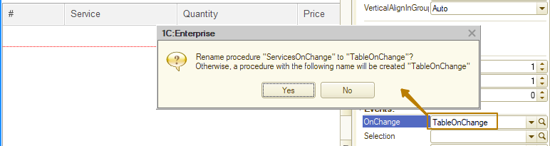
- If you need to remove a handler procedure, you can clear the event field in the properties palette and the platform will prompt you to remove the procedure from the module.
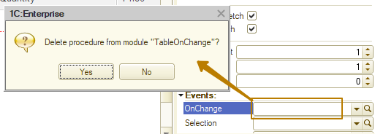
Event order diagram
In one of the previous lessons, I provided a scheme with the sequence of events during the document posting. Now I want you to look again at that scheme, as well as 2 others: the sequence of events when writing a catalog item and the sequence of events when canceling the document posting.
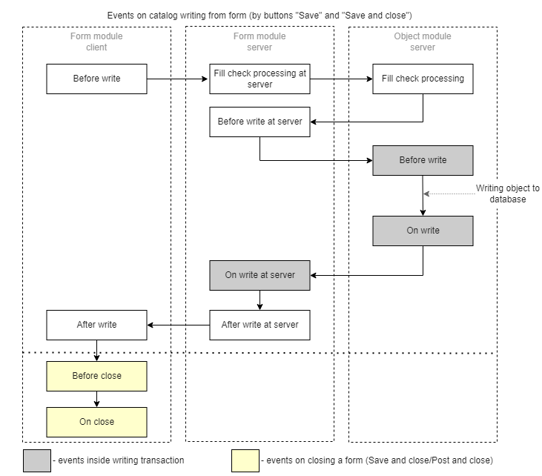
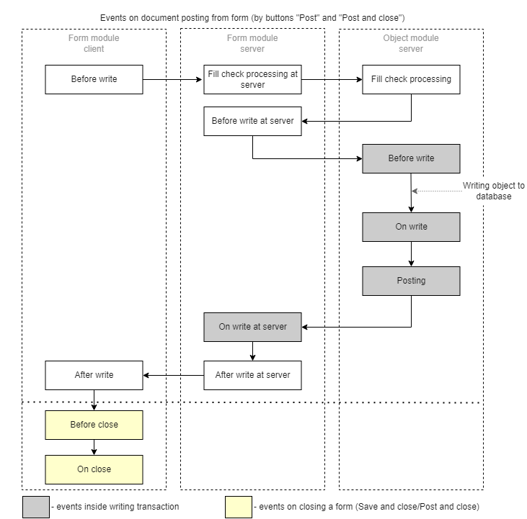
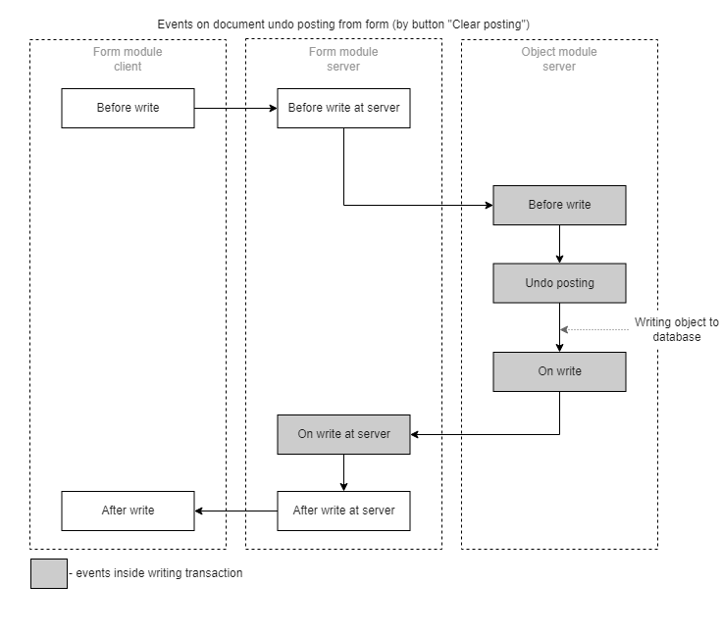
You can see that the scheme of events when recording a catalog item and the scheme of events when posting a document differ only in the presence of the Posting event in the document. If the document is only recorded and not posted, this event does not occur. The moment of occurrence of the FillCheckProcessingAtServer (Form module) and FillCheckProcessing (Object module) for a document during interactive work depends on whether the Posting property of this document is enabled. If the property is enabled, then the filling check is triggered during an interactive work only when posting a document; if disabled, then when writing, and the document will not have commands for posting or canceling posting.
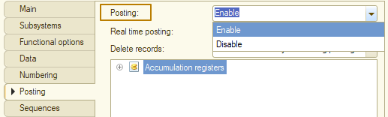

Let's consider the events from the document events scheme in the order they follow.
Form module. BeforeWrite(Cancel, WriteParameters)
This client event occurs first when writing, posting, or canceling a posting. In this event, client operations can be performed: checks, preparation of data available only on the client, interaction with the user (for which it is necessary to implement a scheme in which the recording is canceled until a response is received from the user, after which the recording is made from the code, but with a separate sign, indicating that user interaction is no longer required).
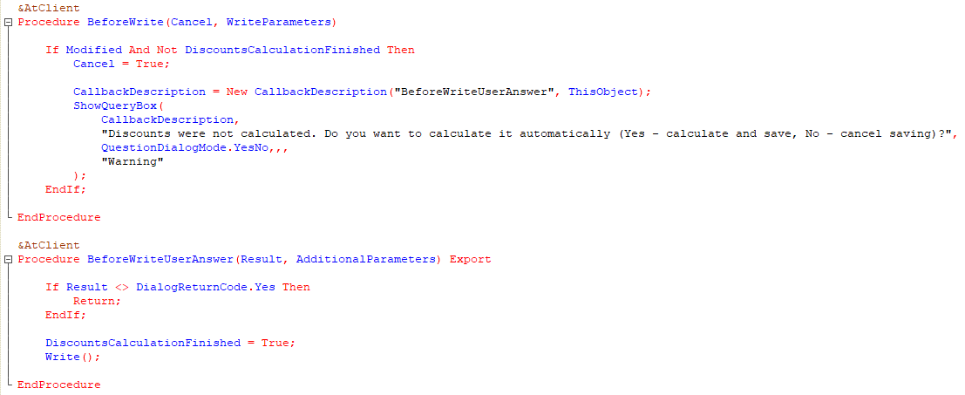
The WriteParameters parameter of the handler procedure contains a structure of a predefined type depending on the type of object; for a catalog the structure is empty; for a document it contains 2 properties:
WriteMode (DocumentWriteMode type) with possible values: Write, Posting, UndoPosting
PostingMode (DocumentPostingMode type) with possible values: RealTime, Regular.
This structure can be supplemented with any other properties, for example, it is convenient for transferring any data from the client to the server events BeforeWriteAtServer, OnWriteAtServer, AfterWriteAtServer.
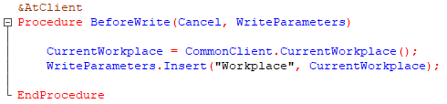

Form module. FillCheckProcessingAtServer (Cancel, CheckedAttributes)
Object module. FillCheckProcessing (Cancel, CheckedAttributes)
These events work identically, only the first of them is executed for the form and its attributes, and the second for the object and its attributes/tabular sections. We've already covered the FillCheckProcessing event in detail, so I won't repeat that information. When the form contains some attributes for which the "Required field" property is set to "Display error", the path to this attribute goes into the CheckedAttributes array and its filling will be checked by the platform. Please note that the form has the "AutoFillCheck" property, which is enabled by default. When disabled, an interactive writing from such form does not trigger both of these events.
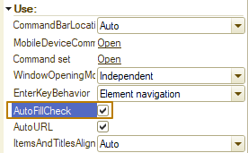
Note: both events are only triggered when there is an interactive writing (by the user from forms). When writing programmatically (writing or posting using code) they are not called. To check when writing programmatically, you need to use the object's CheckFilling() method, which triggers the launch of these events.
An event handler in a form module can be used, for example, when the form has attributes that make it easier to work with the object, but the data from which does not need to be stored in the object. For example, the document contains the DeliveryAddress attribute, in which the user must enter the full address for delivery of the goods to the customer. At the same time, we do not want to allow the user to enter the address manually, because there is a strict format for filling out and even an extra or missing comma between the city and the district can lead to problems when subsequently working with the company that performs the delivery. Therefore, the developer adds the attributes City, District, Street, Building, Apartment to the form, which are required to be filled out if the “delivery required” flag is turned on in the document. In the BeforeWriteAtServer event, the developer implemented an algorithm that places data from these details into the document attribute DeliveryAddress according to the address generation rules.
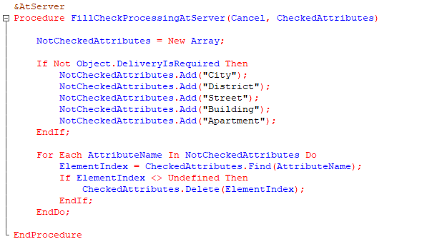
Form module. BeforeWriteAtServer (Cancel, CurrentObject, WriteParameters)
This is a server event, the handler procedure contains the parameters Cancel, CurrentObject, WriteParameters. In this event, you can perform some additional checks, such as those that rely on data received in the WriteParameters parameter from the client.
It is important to understand that in this event the form has already been “divided” into a form and an applied object, the data of which will be written to the database.
The developer has the opportunity to access both the data of the main attribute Object of the form and the object itself, which will be written to the database through the CurrentObject handler parameter.
The CurrentObject parameter has the type of "object" class depending on the type of the object being written (in the case of a catalog writing it is CatalogObject, for a document - DocumentObject). That is, an instance of the object class has been created, and you can access its properties and methods, but it has not yet been written to the database.
Note: CurrentObject is an object that will actually be recorded in the information base and if you need to make any changes of the object, fill in the details precisely through the CurrentObject parameter. Making changes through the Object form attribute will not give any result in this event handler, so this attribute can only be used read-only, but it is better not to use it at all, because when you change data with the CurrentObject object, these changes will not be reflected in the Object attribute. I repeat once again: although the platform still allows you to work with the Object form attribute in this event handler, no changes to this attribute before the write transaction is completed will be written to the infobase. After the write transaction is completed (see the diagram with the order of events), the data from the CurrentObject will be written to the Object.
You also need to understand that when writing an object programmatically (from code), this event will not be called, like any other events located in form modules. Therefore, if any algorithms must be executed in any way of writing object data, and not just when writing from a form, they should be placed in the object's event handler (BeforeWrite), and not in the form's event handler.
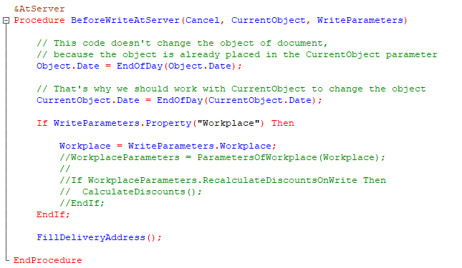
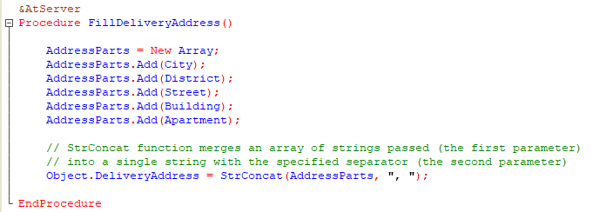
Start of transaction
Object module. BeforeWrite (Cancel, WriteMode, PostingMode)
The first event after the start of a write transaction. For documents, this event contains two additional parameters: WriteMode and PostingMode. These are the same parameters that were in the BeforeWrite and BeforeWriteAtServer events in the form module, only there they were located in the structure properties of the WriteParameters parameter.
Typically, this event handler is used to complete an object (for example, a document contains the TotalAmount attribute, which stores the sum of the document for all its tabular sections: Products, Services, etc.). This handler is also used to prepare data for subsequent operations, such as posting (if the algorithm is based on data that was in the document before recording), some kind of processing, for example, you need to implement an algorithm in which changes in the status of the document are written to the register. In this case, you can get status values from a link to the document (if the document is not new) or consider the status empty (for a new document), compare it with the current status, and then add information to AdditionalProperties about whether the status has changed, so that if the document is successfully written later, perform further steps to record information about the new status in the register.
If for some reason the document writing should be canceled, here, as in other events, you should use the Cancel option.
Note: Before the end of this event, the object is still not written to the database. If you receive data by reference to an object (which exists only if something other than a newly created object is being written), then this will be data without taking into account all the changes that the user could make in the form, as well as those that were made from the code in the BeforeWriteAtServer and BeforeWrite handlers.
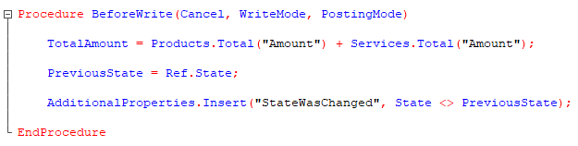
Object module. OnWrite (Cancel)
The first event after writing an object to the database. The new object already has an object reference. If you need to cancel a write transaction, you must set the Cancel parameter to True. Typically, a handler for this event is used to write data associated with an object. As in the example above, if the status of a document has changed, you need to write information about this event in the register in the format
Document ref - State - Date - Author
If an error occurs while recording the status history, the transaction must be canceled either explicitly (by raising an exception or using the Cancel parameter) or implicitly (if an exceptional error occurs, for example - division by zero). If there are no errors, then both the document and information about its new status will be written to the database in a single transaction.
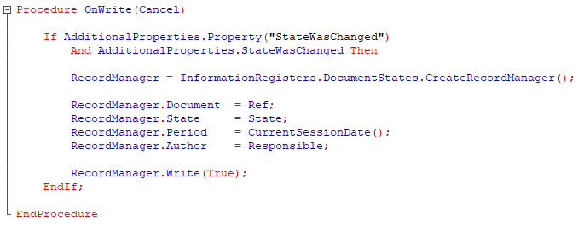
Object module. Posting (Cancel, PostingMode)
We have already become acquainted with this event in lessons on registers. It is performed only when posting a document, interactively or programmatically. If posting is disabled for a document, this event will never run.
The main purpose of the event is the formation and recording of movements in registers, as well as checks related to movements in registers (for example, checking that after the posting transaction there will be no negative balances of goods in warehouses).
The PostingMode parameter determines how the document will be posted: real-time or backdated.
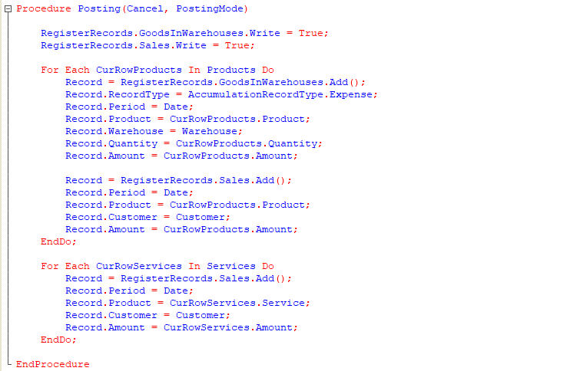
If automatic deletion of movements on the Posting tab is set for a document in the configuration (for a new document this is the default value), then before the event occurs, all register records by the document will be deleted automatically, otherwise they will have to be deleted programmatically.
Form module. OnWriteAtServer (Cancel, CurrentObject, WriteParameters)
This event is raised after an object is written to the database, but before the write transaction ends. The last event to cancel an object write in a transaction.
The purpose of this event handler is to write additional information related to the data of the object being written to the database.
To some extent, it is analogue to the OnWrite event of an object module.If the data for recording additional information is in the object itself, then we use the object module handler OnWrite(). But if the data is in the form, then this event is intended precisely for such cases, because it has access to the form data.
This event handler is also used if you need data from the handler procedure's WriteParameters parameter, which, as we previously learned, is passed between form events associated with a writing.
The object data that was already written to the database when this event occurred is found in the CurrentObject parameter. This parameter has a class type of Object (in our case, DocumentObject). You can access its properties and methods, and also use it to call the object's export methods.
You should work precisely through this parameter, that is, not to confuse it with the main attribute of the Object form, since there the data that was there before recording and its changes are useless because after executing this handler, the data from the CurrentObject parameter will be written to the form attribute of the Object.
If this is a record of a new object, then CurrentObject.Ref will contain the value of the reference to the current object in the infobase. But when accessing Object.Ref for a new document, it will have an empty ref at this stage.
So, about this event handler we can draw the following conclusions:
- If you need to perform any actions related to the recorded object (calling object methods, receiving data from the object), you must use the CurrentObject parameter.
- If you need a ref to a newly created object, you should use the CurrentObject parameter (CurrentObject.Ref) for it.
- The main attribute Object of the form can only be used to compare what “was” with what “was recorded” in the database.
- If you need to change the recorded additional data based on the form data and object data, then you must use this handler.
Since such parts of the address as City, District and others are not stored in the object, but are selected on the form for further generation of the address and placing it in the document details, it can be convenient to store these parts of the address and select them from the list instead of manually entering them every time. Then imagine that my program implements the following mechanism: the user starts entering a string in the address fields; if such parts of the address were used in other documents, auto-completion of the entered string will be available in the field. For example, the user entered the value “San”, and in the field he is offered a choice of 2 values: San Francisco and San Diego. However, he may not select a value from those offered, but enter the value San Sebastian. After a document with such a city has been recorded, we should save this value in a separate object and also offer it to the user in other documents.
So, the implementation of such an algorithm should be placed in this event handler, since we want to write in a transaction in order not to create unnecessary address records if the document was not recorded for some reason, while City, District and others address fields are not stored in the object and are not available in the OnWrite event of the object module.
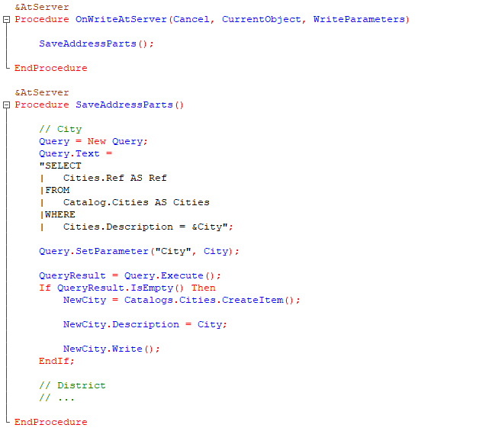
Completing the transaction
Form module. AfterWriteAtServer (CurrentObject, WriteParameters)
After the write transaction completes, the written object data is converted to form data. After this, this event handler is called. It is too late to cancel writing an object in this event handler, so there is no Cancel parameter in it. This is the last handler in which the form data and the object that was written are available separately.
This handler is used when actions are expected on a form, and these are actions that should be performed only when the object is guaranteed to be written to the database (after the transaction has completed). For example, outputting of some additional information associated with the object's data in the form or performing some action that should only be performed if the object is guaranteed to be written.
However, here the CurrentObject parameter should be used exactly the opposite of what it was in previous write events. In this handler, the data of the recorded object is already placed in the form, i.e. is already loaded into the main attribute of the Object form and therefore there is no point in changing the CurrentObject: it will be destroyed when the event handler exits. But the CurrentObject can be used to perform some auxiliary actions by accessing its properties and methods, as well as by calling the object’s export methods (I remind you that the CurrentObject is a value of an object type). For example, if at this stage you need some data or methods of an object, you need to use CurrentObject, and not try to get them through the main attribute of the Object form.
The WriteParameters parameter is still available, it still contains data that could have been transferred from other handlers.
An example of using this handler in the context of the document Sales invoice: suppose users of this document want to see how many goods and services were sold within the current month. From an application architecture perspective, this data is dynamically populated and does not require storage in a document. When a user changes a product or service in the Products or Services tables, as well as after he posts a document, the values in the table columns should be updated. For such an update, the AfterWriteAtServer event is suitable.
To implement this example, I add an attribute column to the tabular section in the form attributes section, calling it SoldThisMonth. Next, I write a query for sales turnovers from the beginning of the month to the end of the day of the document date. Then I need to run this query and fill the column with the value selected in the query.
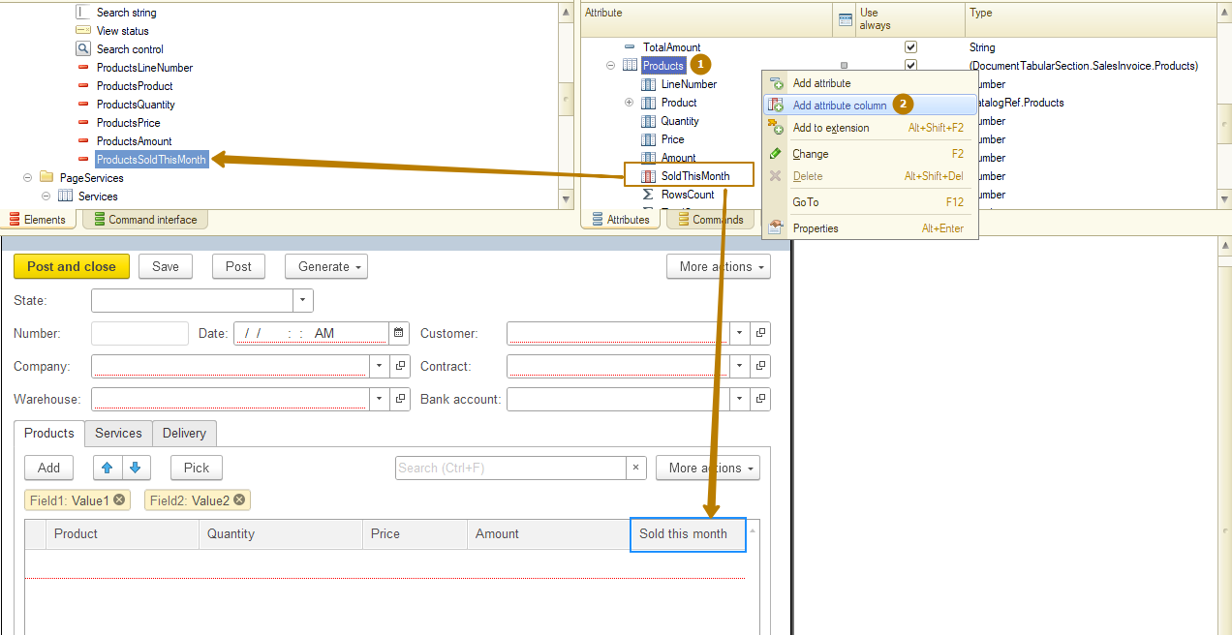
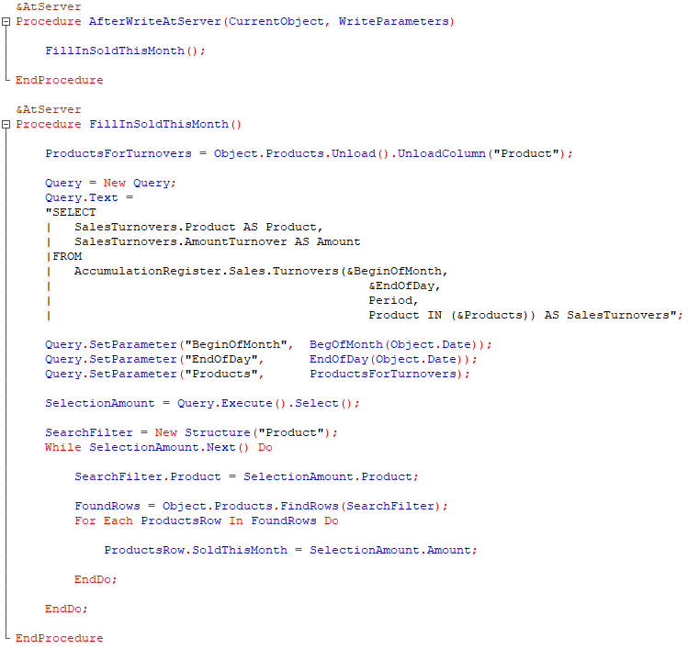
Form module. AfterWrite (WriteParameters)
After processing the AfterWriteAtServer event, the form is sent to the client. The application object is destroyed in the server memory. Changed attributes, elements and form parameters required for display are transferred to the client. The form object on the server is destroyed.
Next, this client event is executed, the last of the key events in the object writing process. Its handler can be used to visually display something on a form, organize a dialogue with a user (for example, display a warning), or notify the user or the user's open forms in the program that an object has changed.
The WriteParameters parameter contains data that could have been passed from the handler of any previous event associated with the writing.
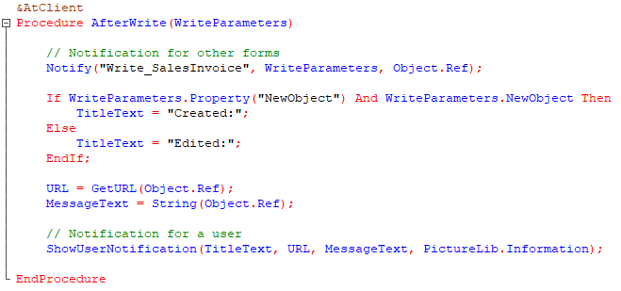
This is how a user notification looks like:
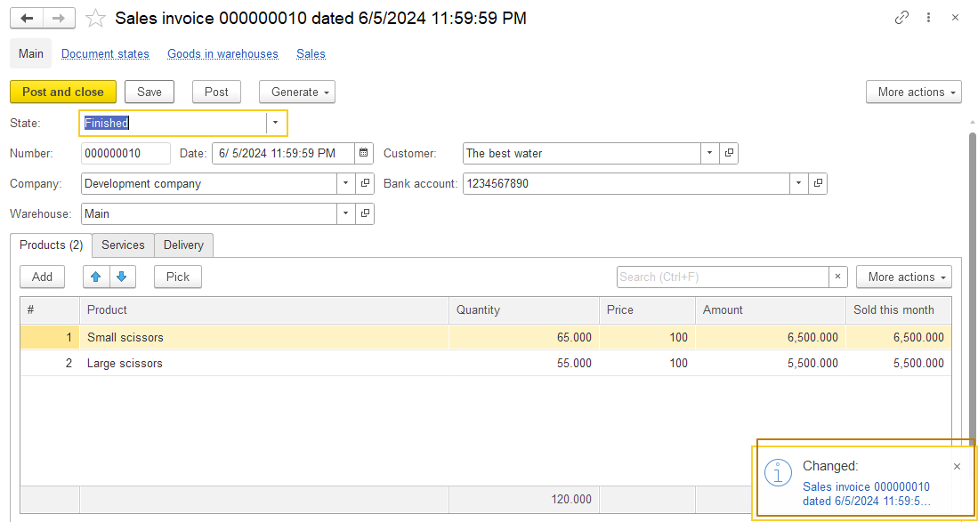
Let's consider 2 more events from the document posting event diagram, which relate not to writing an object, but to closing, including the one that occurs when the user clicks the commands "Post and close" or "Save and close". These are BeforeClose and OnClose events that occur on the client and it is prohibited to make server calls from them.
Form module. BeforeClose (Cancel, Exit, WarningText, StandardProcessing)
As I already noted, this is a client event. The main purpose of this event is to analyze whether the form can be closed or not. And if for some reason it cannot be closed, then cancel its closing.
The handler for this event contains 4 parameters, 2 of which are already familiar to us - these are Cancel and StandardProcessing. Setting the Cancel parameter to True on this event causes the form to not be closed when the event ends. But with the StandardProcessing parameter the situation is the opposite; let’s look at the effect of this parameter on the behavior of the application using an example. If a document is open whose form has been modified and the form window is closed by pressing the Esc key or by clicking the close window button, the platform will report that the form data has been modified and will offer to either write it down, close it without saving the changes, or refuse to close the form. If in this situation you set StandardProcessing to False, then the form will be closed without questions in any case, regardless of whether the data in it has been modified or not.
The other 2 parameters are Exit and WarningText.
Using the Exit parameter, the developer can determine whether the form closes on its own or whether the form closes as the application shuts down. This parameter is set to True if the user tries to close the main application window. When closing a separate form, this parameter will be set to False.
When closing the entire application and when refusing to close a specific form, using the WarningText parameter, the developer can set a text message that will be shown to the user, with the opportunity to refuse to close or confirm it (in the web client, all messages will be combined into one dialog).
If the value of the WarningText parameter is not set, then the line “The data is changed. All changes will be lost.” will be displayed as the warning text in the dialog.
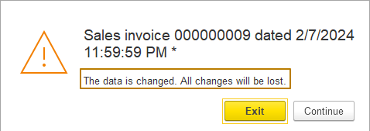
Let's consider an example of implementing a dialogue with the user in this event. Since the question dialog is non-modal (does not pause code execution), such an implementation requires dividing the algorithm into 2 parts:
1) ask a question, canceling the closure by setting the value of the Cancel parameter to True
2) get a response, and if the user agrees to close the form, cause it to close programmatically, noting in a separate attribute the need to close the form without asking the user before closing.
I create a CloseWithoutChecking attribute on the form with the Boolean type. The default value for this type is False. Before closing, I check if this attribute is not equal to True, and the form is modified, then I set the Cancel parameter to True and ask the user a question.
In the response handler, I check the user's response if he agreed to close the form, set the CloseWithoutChecking value to True and call the Close() method.
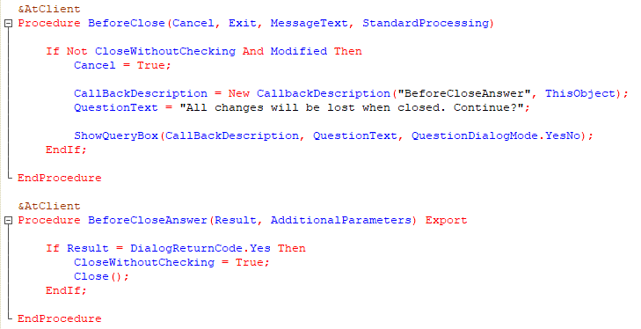
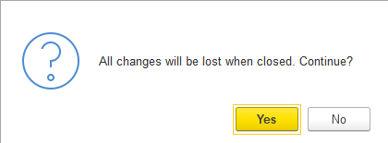
Of course, in the forms of objects such as catalogs, documents, registers (item form, document form, record form), there is no need to implement such a dialogue with the user, since the platform automatically controls the possibility of losing modified data. But in other forms, for example common forms, data processor forms (which we will learn about a little later) and even list/choice forms of objects the platform rarely performs these checks, so sometimes you have to implement a similar algorithm. Also, in addition to checking for changed data, there may be other dialogs with the user.
Form module. OnClose (Exit)
After processing the BeforeClose event, the form is closed and the user no longer sees it. However, the program object of form still exists, and the form's OnClose event is called on the client.
The purpose of this event is to perform actions that should only be performed if the form is 100% closed. For example, close an auxiliary form that exists only if the main form is open. Also in this event, the trading equipment is turned off, which is connected to the form in the OnOpen event.
The OnClose event handler receives a sign of the conditions under which the form is closed with the Exit parameter. But we must keep in mind that it is impossible to refuse to close the form in this handler.
After this event is processed, the form program object is removed from the client memory.
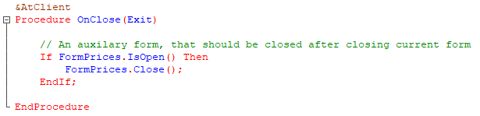
So far we've seen object events and some form events. It's time to get acquainted with some commonly used form element events.
Form field events
Let's start with the input field events, but I will skip the OnChange event, because we have already used it several times and have nothing to add about it.
StartChoice (Item, ChoiceData, StandardProcessing)
In this and other form element event handlers, the Item parameter stores the form element/item for which the event was triggered. For example, if the user tries to select a value in the Product field of the Products table, the Item parameter will contain this same ProductsProduct field of the form table.
The ChoiceData parameter contains a list of data from which the user can select. Usually this parameter is empty and has the value Undefined, but you can disable standard processing (StandardProcessing = False), and assign the parameter the ValueList with the values that should be given to the user to choose from. For example, if we know in advance that such a list will be limited to a small number of elements (up to 10) and we do not need to open a separate form in which the user would select a value.
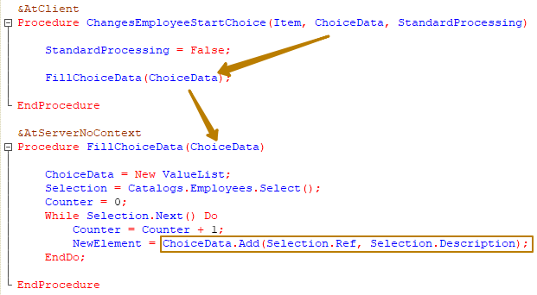
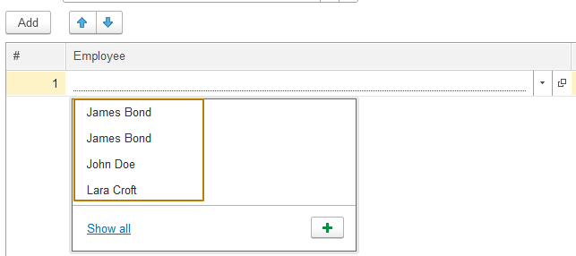
You can also disable standard processing and implement opening a choice form with the execution of your own algorithms. The example of such an algorithm was given in the previous practical task, when you had to implement a button for selecting batches into a document table based on the product, date and warehouse passed through parameters. Only in the case of the button, a command was used, not a form item event.
Implementation through an event handler is to some extent even simpler than through a command, since when passing a field to the “Owner” parameter of the OpenForm method, the selected value will automatically be inserted into the cell in which the selection occurs, without the need to separately handle the selection event.
I want that in the PersonnelChange document with the type of operation “Dismissal”, when selecting an employee, it would be possible to select only employees who are already working in the company from the document on the date of the document. To do this, I created an Employees information register and added an algorithm for adding records to this register from the PersonnelChange document. I won't demonstrate this part because you have already created such algorithms before. Instead, let's look at the implementation of the algorithm for selecting working employees from the StartChoice event handler.
I am creating a new choice form for the Employees catalog, but I am not making it the default choice form so that it opens only programmatically.
Then I set up a dynamic list in the form, enable the CustomQuery property and write a query to the Employees catalog and the Employees information register. The catalog is needed so that I can select it as the main table in the list settings, then when selecting a value, the platform will return a ref to the selected catalog element and I will not have to describe the algorithm for filling a field in the table with the selected value.
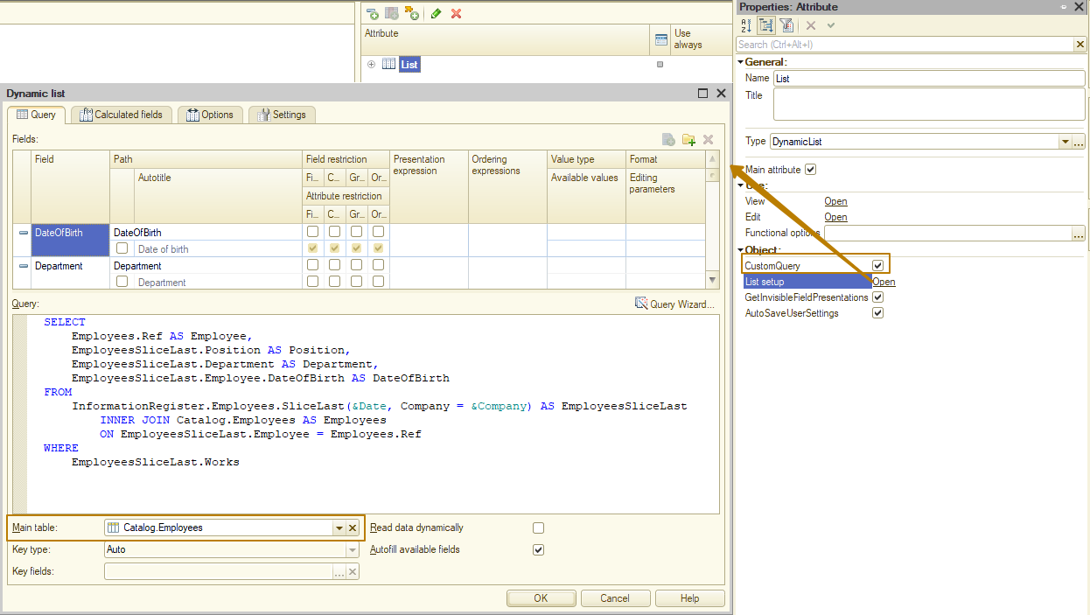 Next, I create the OnCreateAtServer event handler and in it I check whether the form parameters have the Filter property; if not, I raise an exception, because I must set the Date and Company parameters in the dynamic list query. After checking, I fill in the parameters of the dynamic list from the Filter structure.
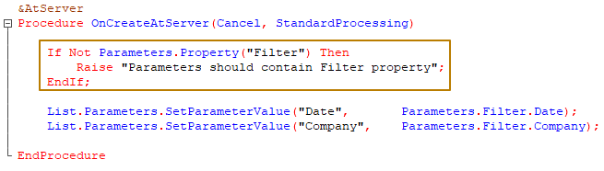

Since I should open a new form only for the dismissal operation kind, then in the event handler for the StartChoice event, I first check the operation kind, if it is equal to Dismissal, then I disable standard processing so as to disable the default platform behavior and call the form opening, passing the date and company there as a filter, as well as the item for which the event was triggered as the owner of the opened form:
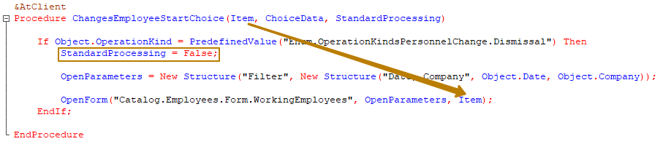
Now, in the form that opens, only employees who work in the company from the document on the date of the document are available for selection:
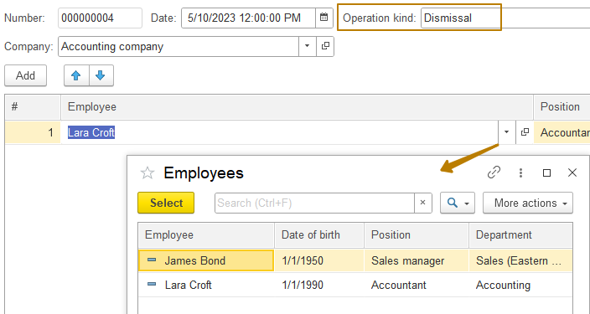
Note: For the date field, the select button looks like a calendar, and for a number field, it looks like a calculator, but it is the same select button with the same event handler as the one we looked at.
Clearing (Item, StandardProcessing)
This event occurs upon a clear command in the text field (when you click the clear button, which can be enabled by selecting "Yes" in the "ClearButton" property of the input field, as well as when using the hotkeys Shift + F4). Typically used if you need to perform related actions when clearing a value, for example, when clearing the Customer value, there is no point in saving the value in the Contract field, because the contract must be related to a specific customer.
Setting the StandardProcessing parameter to False will disable clearing the value in the field.
Tuning (Item, Direction, StandardProcessing)
This event occurs when using scroll buttons, which can be enabled by selecting Yes in the SpinButton property of the input field.
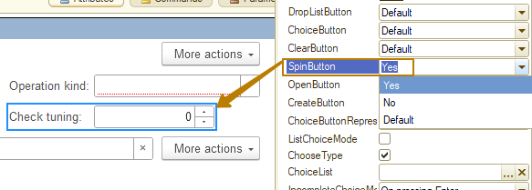
These buttons are enabled when it is necessary to provide the user with a convenient way to switch to the next value in order, and this does not necessarily have to be a number. You can, for example, implement filling a field with a value corresponding to the beginning of the month, displaying the value <Month Year> in the field, and when a user presses the control button, change the month to the next or previous one (depending on whether the user pressed the up or down button).
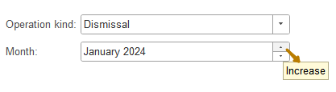
The Direction parameter has the Number type and contains the value 1 if the user pressed the "increase/up" button, and -1 if the user pressed the "decrease/down" button.
Opening (Item, StandardProcessing)
This event occurs when using the open button, which can be enabled by selecting Yes in the "OpenButton" property of the input field.
The open button is present by default on the form for fields associated with reference type details.
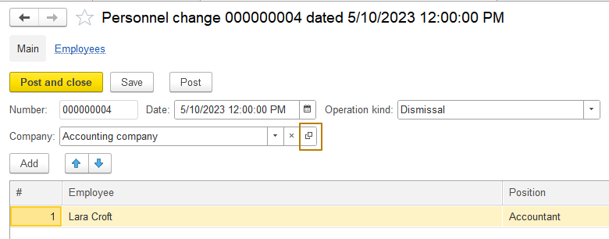
You can disable this button by setting the "OpenButton" property of the input field to No. It can also be enabled for fields associated with values of any type, even primitive ones, then standard button click processing will open a window in which it will display the current value in string form
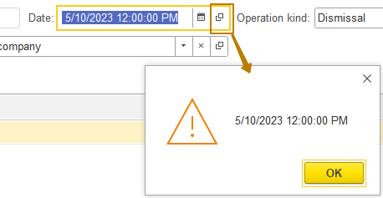

Standard behavior can be overridden in a way that is already familiar to us - by setting the StandardProcessing parameter to False and writing your own algorithm.
ChoiceProcessing (Item, SelectedValue, StandardProcessing)
The good thing about this event is that it is called after a user has selected a value from the list provided, but before that value is placed in the input field. Therefore, in this event you can:
- refuse the choice made by the user (StandardProcessing = False);
- place a different value in the input field than the one selected by the user (SelectedValue parameter).
The first situation may seem strange at first glance. If the user can choose “something wrong,” then why offer him to choose it? It is necessary from the very beginning to allow him to choose only from what is “possible”.
This approach is usually correct. However, it has two disadvantages.
The first disadvantage is “usability”. For example, a user starts typing "Excellent supplier" into a purchase document. He knows for sure that such a supplier exists in the database. But the program does not offer him to choose this supplier. If the restriction on choice is not obvious and is not included in the help information for the program, then the first thing the user will think is that the program is "broken" or that he writes the supplier incorrectly. The user may not think at all about the fact that this particular supplier cannot be selected in this particular document, or will only guess about it after a long time of experimentation.
Therefore, in some cases it is more logical to do the following: if the user wants to select a supplier with this name, provide him with this opportunity. But if for some reason this provider cannot be used in this document, after selecting the user, inform him about this and discard the choice made by the user.
Such a scenario, of course, is not a dogma, but in a number of cases when the fact that one can choose among a limited set of elements is not obvious to the user, this scenario has a right to life.
Another disadvantage of initially limiting the selection list may be purely technological. For example, figuring out whether a given supplier can be used or not requires a number of very complex calculations that can only be done for one supplier at a time. Let's say the choice list generated for the user will contain 49 elements. For all of them you will need to perform this calculation. This may take considerable time. As a result, the user will select one single element from these 49.
In such a situation, it will be much more productive, without calculating anything, to provide him with 49 elements to choose from. And after he selects a single element, carry out the necessary calculations only for him alone and either agree with the user’s choice or refuse it.
As for placing a value of a different type in an input field, this situation may arise when simulating string input performed by the platform. For example, when the input field is of string type, the selection list is formed from catalog elements, some service information is filled in based on the user’s choice, and not the link selected by the user, but its representation is placed in the input field.
You can perform all these actions in the ChoiceProcessing event handler.

Form table events
Let's move on to the events of the form table. The set of available handlers depends on the type of data that the Table form element is associated with. Some events overlap for different data types, some are unique for a specific type (table of values, tree of values, tabular part of an object, dynamic list, list of values)
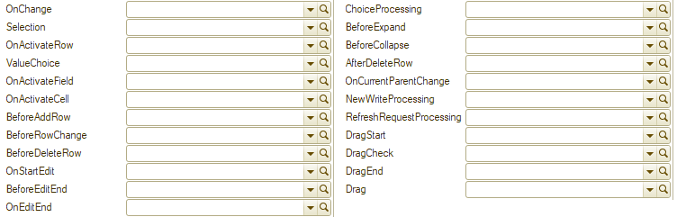
OnChange (Item)
The OnChange event of the form table is similar to the form field OnChange event - it is also called after the change has occurred, only in the case of a form table, the event is called when any change occurs within the table row. For example, there is a form table Products with 4 columns: Item, Quantity, Price, Amount. In the document, one row has been added to this table. So, when a value changes in any column of this row, the OnChange event of the Products form table occurs, i.e. if you add a new row and fill it with a value in all 4 columns, the event will occur 4 times. Therefore, we can say that the handler for this event is universal and should not be used for any cases, for example, to recalculate the amount in a line when the quantity and price change. It should only be used if some algorithm must be executed every time there is a change in the table row.
But there are some cases when it’s normal to use this event handler. For example, if for different events (selection, change, clearing) in different columns you need to execute the same algorithm, it is easier to use the OnChange event of the form table, but provided that the called algorithm does not require many resources. Otherwise, it is better to call it only from certain places separately.
Actions such as adding or deleting a row do not trigger this event.
Selection (Item, SelectedRow, Field, StandardProcessing)
This event occurs when you double-click any cell in a table row or when you select a row and press Enter, i.e. it is responsible for the user selecting a row from the table. This event also occurs when you press the standard "Select" button in a form in which the form table associated with the main form attribute has the "Selection Mode" property enabled.
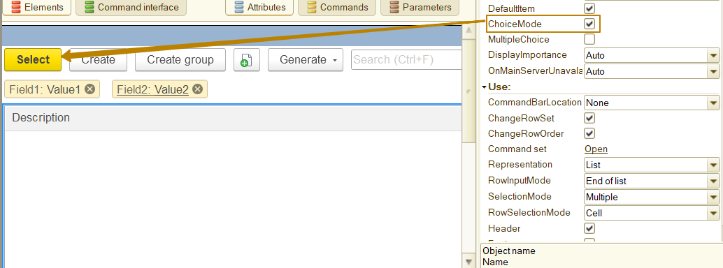
The SelectedRow parameter can have different types depending on the type of the attribute the form table element is associated with. For a tabular section or a value table, the type is a number, this is the row identifier (not to be confused with the row number of the tabular section). In order to get a row of the tabular section by this number, you should use the FindByID(RowIdentifier) ​​method:
ProductRow = Object.Products.FindByID(SelectedRow);
The Field parameter contains the form element, this is the current form element at the time of selecting the table row (in other words, this is the table column). Thanks to this, it is possible to implement a mechanism when the selection processing algorithm differs depending on the column in which the selection is made. For example, there is a table that is filled by pressing a button and the user is prohibited from manually editing this table by enabling the ReadOnly property (it is impossible to add and delete rows, as well as edit data in rows using standard tools). It should be noted that the cell editing mode in such a table is disabled, which means that the user does not have access to the field buttons, including the open button, the select button.
But what if you need to provide the user with the ability to quickly open objects by links from the data in the table? Or enter the creation of a new object if the user has made a selection from a specific table column?
This is exactly what you can use the Selection event handler for and write different processing algorithms for different fields.
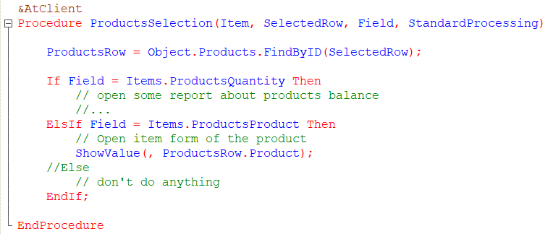
The ShowValue() method shows the value passed to the second parameter in the dialog box without waiting for it to close. The type of dialog box depends on the type of the passed value.
OnActivateRow (Item)
This event is used when it is necessary to perform some actions when the user selects a row. Typically, this is: displaying additional information in a form, setting a filter on another table’s rows (one list/table is subordinate to another, for example, when selecting a country from one list, leave only the cities of this country in another list), and updating the properties of form elements (for example, controlling the availability of a button when selecting different rows).
Important: when working with this event, you should avoid context server calls, since this can lead to the fact that when returning to the client, the form will be updated, which means the current row in each table will be re-activated and the OnActivateRow handler will be called again. If a context server call still needs to be performed, you should use the attachment of a client Idle handler, from which you can perform a server call. Such an Idle handler calls the procedure specified in the first parameter after a time interval specified in the second parameter once or multiple times (depending on the value of the third parameter).
Note: Idle handler is a client procedure called at a specified interval by the 1C platform mechanism, which is enabled using the AttachIdleHandler client application method. The procedure connected via the Idle handler must be exported and must not contain parameters. For details, see the syntax assistant.

Non-context server call:
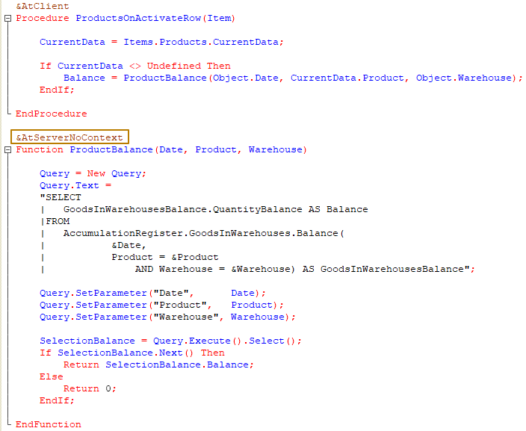
The result:
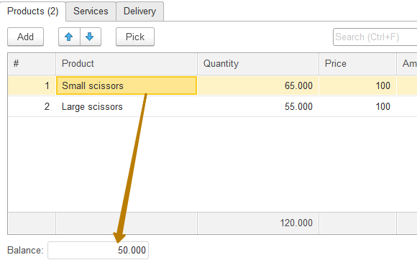

Context server call:
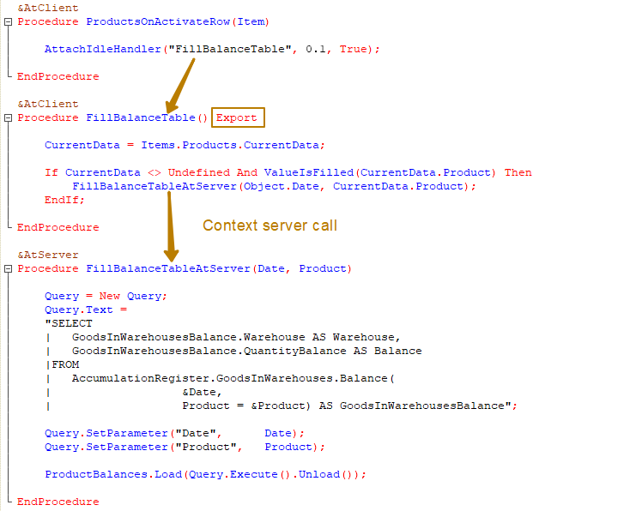
The result:
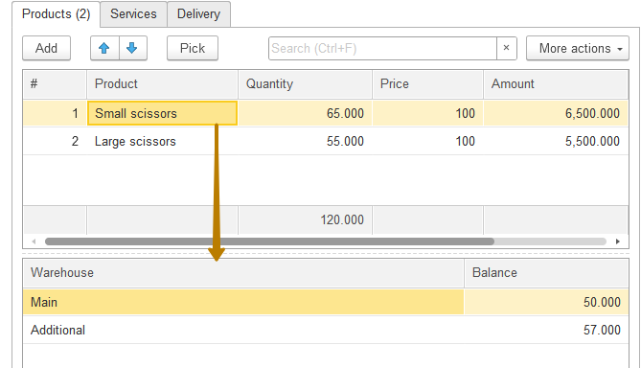

BeforeAddRow (Item, Cancel, Clone, Parent, Folder, Parameter)
This event occurs when a row is added interactively to a form table using buttons or hotkeys. Typically, the handler for this event checks whether adding a row to the table should be prohibited for some reason. If so, the Cancel parameter is set to True and the row will not be added to the table.
The Clone parameter specifies whether the row is added by copying another row (in this case, the value is True).
The Parent and Folder parameters are meaningful only for hierarchical catalogs and charts of characteristic types.
The Parent parameter specifies the subordination of the created element to another element or group.
The Group parameter specifies whether an element or group is created (usually in the form of a list or selection). If the parameter value is True, a group is created, otherwise an element.
Note: In the handler for this event, you cannot use server methods of the form with the &AtServer compilation directive and you cannot change attributes that can lead to a server call.
BeforeRowChange (Item, Cancel)
This event occurs before entering the table row editing mode. It is usually used to override the logic of entering the row editing mode (for example, opening the form of the related object) or simply prohibit editing in the row (for example, after performing some check) by setting the Cancel parameter to True.
OnStartEdit (Item, NewRow, Clone)
This event occurs after entering the table cell editing mode, but before making changes. It is quite often used together with the BeforeStartAdd event to automate operations in certain cases. For example, if a row was added by copying, it may be necessary to clear some columns in the added row, such as RowIdentifier, which can be added by the developer so that the row can be uniquely identified without being tied to the row number (since the number can change automatically after changes in row set or order). It is also used to fill in certain columns when adding a new row.
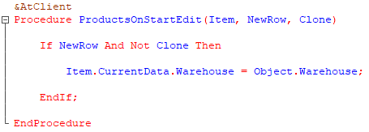
The NewRow parameter specifies whether the newly added row or the previously existing row is being edited.
The Clone parameter specifies whether the new row was added by copying.
BeforeEditEnd (Item, NewRow, CancelEdit, Cancel)
This event occurs before the end of editing a row, i.e. when pressing the Enter key, executing the "Finish editing" command, or clicking the mouse in another row of the table field. The event also occurs when pressing the Esc key, in which case the CancelEdit parameter of the handler procedure takes the value True.
The event is usually used to override the standard behavior or for cases when it is necessary to check the correct filling of the row immediately after editing (in this case, the Cancel parameter is set to True and explanatory information is displayed) when an edited row is still active.
The NewRow parameter indicates that editing of the added row is ending.
The Cancel parameter allows you to cancel the end of editing. An important feature of this event is that the handler for this event is called only when editing of the row is finished and is not called when moving from one column of the table field to another (by pressing the Tab key or using the mouse).
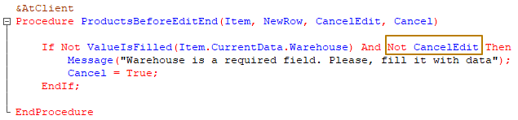
In this example you can see that I additionally check whether the end of the row editing is due to the cancellation of editing (pressing the Esc key by the user). This is important, because otherwise we can create a situation where the user entered the row editing mode, did not change anything and canceled the editing, but we still prohibit him from exiting the editing mode and force him to fill in the field with a value, even if he accidentally entered the editing mode and does not know what data to fill in the field.
OnEditEnd (Item, NewRow, CancelEdit)
This event occurs after a user exits the row editing mode. It is no longer possible to cancel changes in the handler of this event. It is usually used to perform algorithms related to editing data in a table, such as filling in additional data based on the data from the table. For example, you need to recalculate the weight of all the goods in an order or the cost of delivery, which depends on the weight/volume/value of the goods.
Note that the event occurs after the OnChange event of the table. In general, this event handler is selected instead of the OnChange event handler when the data of the NewRow and CancelEdit parameters is required.

Study the rest of the events and event handlers yourself. Try to think of cases in which these events occur.
Event subscriptions
Now that we have become familiar with events and their handlers, it is time to get acquainted with a tool that allows you to process events universally, in bulk, and, if necessary, add your own event handling without interfering with existing modules. This tool is event subscriptions.
It allows you to place event handlers in modules separate from the object, as well as use one handler to handle the event of several objects (and even all objects of a certain metadata class, for example, all documents). This is especially useful when customizing standard configurations, since event subscriptions allow you to flexibly add new handlers without affecting the main configuration code.
An event subscription is a configuration object of the "Event Subscription" type, for which you need to specify the settings:
Source - a list of object types for which an event handler will be specified.
Event - an event whose handler will be defined in this subscription
Handler - a path to an export procedure that will serve as a handler for the specified event for the selected objects.
Note: If you need to include all documents/catalogs/other in the list, you can select the DocumentObject/CatalogObject/other type, then the event processing will be performed for all objects of this class, even for those that will be created later.
Also, only object events can be selected as an event, but not form events.
Let's look at an example of using an event subscription. Previously, we implemented an algorithm for filling an organization in documents with a value from the "Default Company" constant. Let's change the existing algorithm using an event subscription, so that it would be easier to maintain later (it allows not to write the same code in each document).
First, I create an event subscription and call it FillDocumentCompany, and specify DocumentObject as the Source.
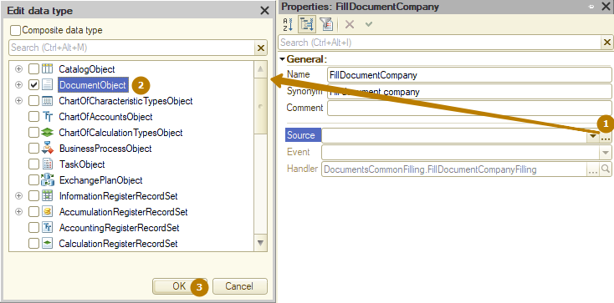
Next, I should select the event during the processing of which the company should be filled. The event Filling is best suited for this.
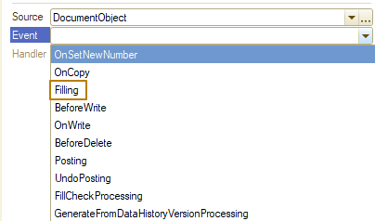
Please note that the list of events depends on the list of sources. If there are different metadata classes, only events that are present in all objects from the list will be available for selection.
Now you need to specify an existing event handler or create a new one.
When selecting an existing handler, the platform checks for export procedures that match the number of parameters among common modules with the "Server" flag enabled.
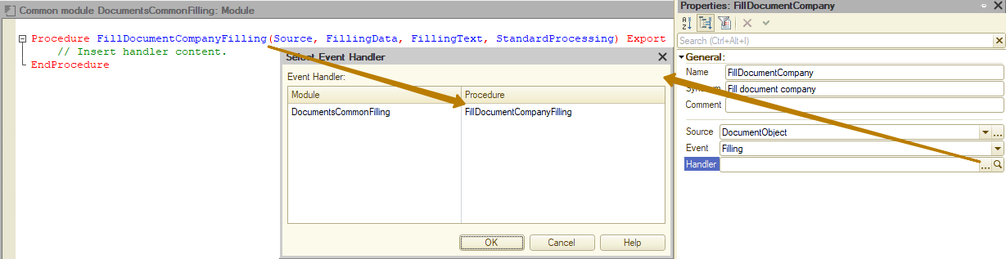
To create a new handler, you need to select a common module with the "Server" flag enabled.
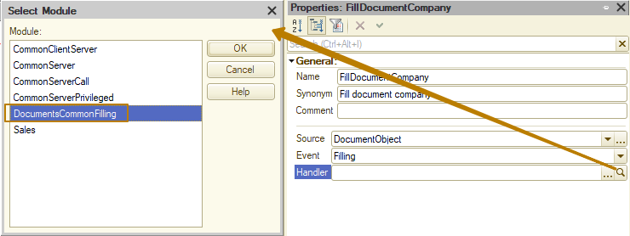
In both cases, the platform allows you to select any common modules with the server flag, even client-server ones, which are not suitable for processing server events, so the developer's task is to independently select the appropriate common module.
Now you need to write code to fill in the company in the handler procedure.
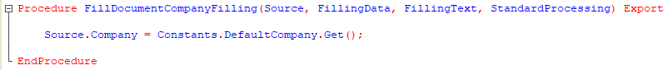
In this case, using an event subscription greatly simplifies code maintenance when creating new documents, because we don't even have to do anything when adding new documents.
However, what if the document does not contain the "Company" attribute or the document's algorithm for filling in a company differs from other documents? Here, we should focus on the rule that we want to adhere to for filling.
If the rule looks like "fill in the attribute in all documents that contain it", then any document (DocumentObject) can act as a Source, but the code must implement a check for the presence of the attribute.
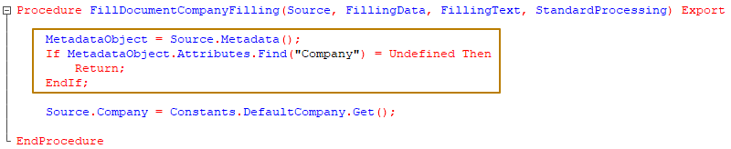
This algorithm obtains the document metadata object using the Metadata() method, and then searches for an attribute by name among all the attributes of the metadata object (the Attributes property of the metadata object). If there is no such attribute (the search returned the Undefined value), then the execution of the code of this procedure should be terminated.
If the rule looks like "fill in the attribute in all documents with a value from a constant, but in some documents fill it in using a different algorithm", then you can also leave DocumentObject as a Source, and implement an alternative filling in the code, checking the source type.
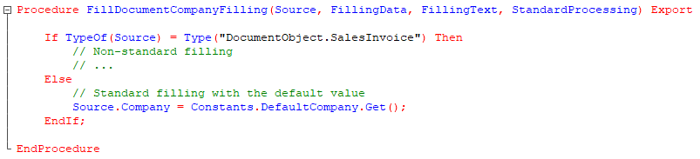
In this algorithm, the Source is checked for its type, for objects with non-standard processing it is performed, for other objects standard processing is performed.
If the rule looks like "fill in the attribute for selected documents that have such an attribute", then it is easier not to select DocumentObject as the Source, but to specify each document separately, then the developer must independently check the presence of the attribute in the document (i.e. select as the Source only those documents that have the attribute, otherwise the subscription to the event does not make sense).
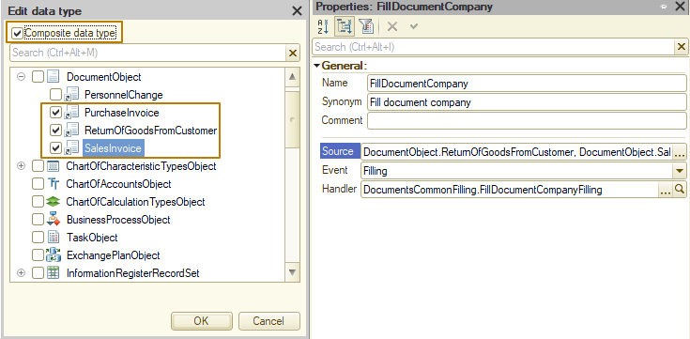
The order of execution of event subscriptions
1) an event subscription is executed immediately after the object’s event handler has been executed. In this case, only object module event handlers can be intercepted and they are executed on the server.
2) event subscriptions for identical sources and actions are executed in the order of event subscription placement in the configuration (metadata) tree from top to bottom.
That is, if there are two subscriptions to the OnWrite event for a document in the configuration, the one located higher will be executed first.
3) subscriptions with a source of a common type (DocumentObject, CatalogObject, etc.) are executed later than with a source of a specific type, even if it is a composite type (several objects are specified).
But what should you do if the standard configuration has a subscription to the DocumentObject Source and you need to create a subscription for a document of a certain type, the handler of which should be executed later than the handler of that standard subscription?
As an option, specify the DocumentObject source in your subscription and place it lower in the list, and check the document type in the handler procedure:
If TypeOf(Source) <> Type("DocumentObject.MyDocument") Then
Return;
EndIf;

